Prompt Engineering
Problem
Your task is to design a system, given a generic question about a company's data, performs two main functions through prompt engineering with a Large Language Model (LLM):
- Transforms the generic question into a detailed, context-specific question. This involves identifying the relevant company and aspects of the query that need specificity. The output should be a JSON object containing the refined question and the name of the targeted database.
- Generates an accurate SQL query based on the refined question and the specified database schema. This SQL query should be capable of retrieving the relevant data from the database.
Deliverables:
- A document detailing the prompts used for both stages of the process, including the rationale behind the prompt design and any iterations or refinements made.
- Examples of generic questions, the JSON outputs generated from these questions, and the final SQL queries produced.
- A brief analysis of the system's effectiveness, including any challenges encountered in guiding the LLM to produce accurate and relevant outputs at both stages.

Solution
Step 1: Define the Database
We use a Student database with normalized tables:
- Students(student_id, name, email, gender, dob, department_id)
- Departments(department_id, department_name)
- Courses(course_id, course_name, credits, department_id)
- Enrollments(enrollment_id, student_id, course_id, semester, grade)
- Attendance(attendance_id, student_id, course_id, attendance_date, status)
- Faculty(faculty_id, name, email, department_id)
- Course_Instructors(instructor_id, course_id)

Step 2: Build Prompt for Stage 1 — Refining the Question Objective:
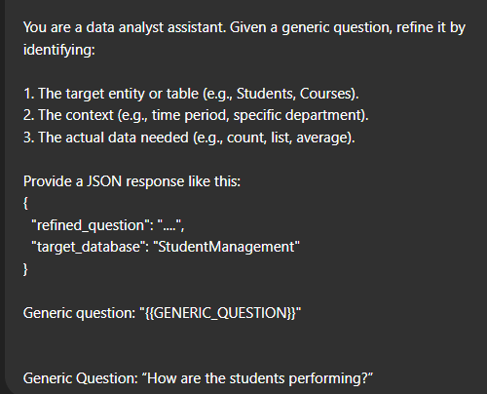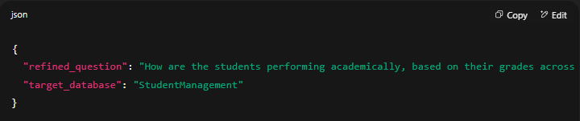

Step 3: Build Prompt for Stage 2 — Generating the SQL Query

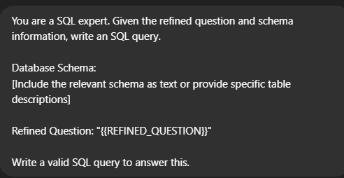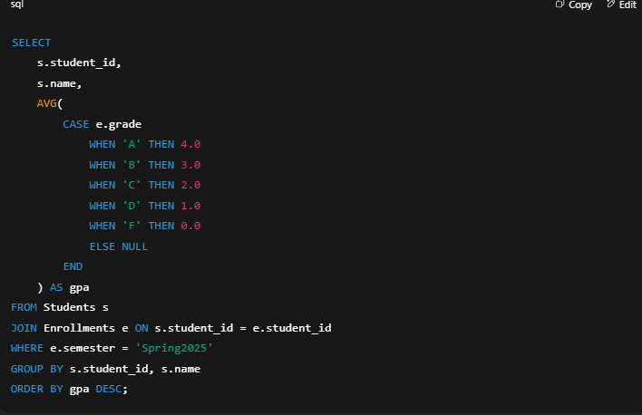

Final Deliverables
1. Prompts
- Stage 1: Refining questions to JSON
- Stage 2: SQL generation based on refined question
2. Examples
- Generic → Refined → SQL for multiple questions
3. Analysis
- LLM is effective in both refining and querying.
- Needs detailed schema and templated prompting for accuracy.

